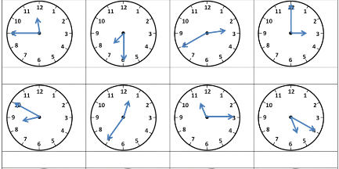

**Vytvor otázky:**

1. you/go/ to school ...................................................................
2. he/play/football ..................................................................
3. when/my mum/relax ..................................................................

**Prelož otázky a odpovedz:**

1. Máš rád pizzu? .................................................................

odpoveď ..................................................................

1. Spievaš pesničky? .................................................................

odpoveď: No, ..........................................................

Odpovedz:

1. Does your mum work in the evening?

No, ....................................................

1. Does your dad watch TV at the weekend?

Yes, ...................................................



**Vytvor otázky:**

1. you/go/ to school ...................................................................
2. he/play/football ..................................................................
3. when/my mum/relax ..................................................................

**Prelož otázky a odpovedz:**

1. Máš rád pizzu? .................................................................

odpoveď ..................................................................

1. Spievaš pesničky? .................................................................

odpoveď: No, ..........................................................

Odpovedz:

1. Does your mum work in the evening?

No, ....................................................

1. Does your dad watch TV at the weekend?

Yes, ...................................................